Finance cube:

**Higher Level depiction of Finance Cube Process**

Gentran/ GENMAST/ GENHMAST

QL Organisation/Activity/Nominal/Company

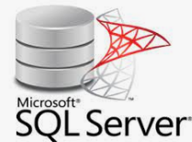  Daily refresh

Daily/full refresh

15 minutes/New tran



Sql GL Finance Datamart

Daily Full/15 min New



SSAS/Multidimensional Cube

Key tables:

Transaction:

Gentran

Budget:

GENMAST

GENHMAST

Key Hierarchy:

General ledger string=Nominal+Organisation+Company+Activity(flattned structure)